

Master Wall Inc.®
PO Box 397
Fortson, GA 31808
706-569-0092
800-755-0825
www.masterwall.com

Master Wall Guide Specification RDCIFS1018
Rollershield Drainage CIFS® Assemblies 10 to 18 year Limited Warranty
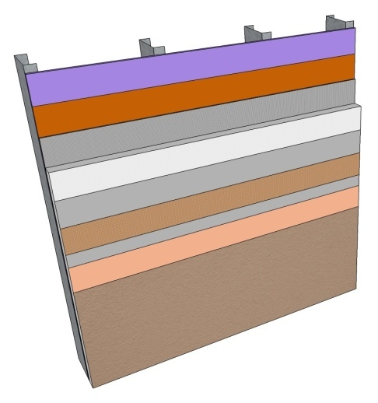
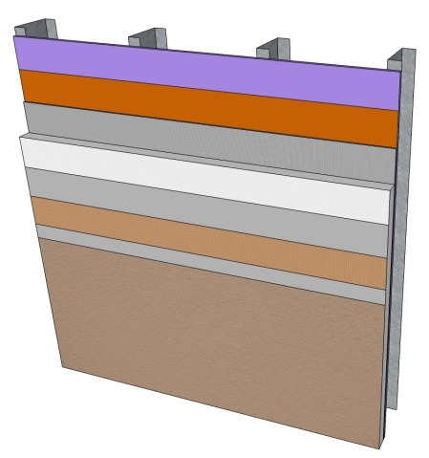

Rollershield Drainage CIFS® 12
- Adds Primecoat Primer
Rollershield Drainage CIFS® 10
- Rollershield Air/Water Barrier
- Master Wall Adhesive
- Master Wall Insulation Board
- Standard Mesh minimum
- Master Wall Base Coat
- Superior Finish

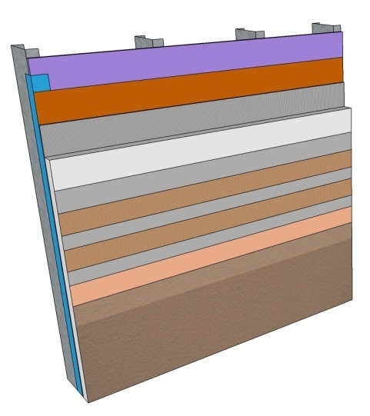

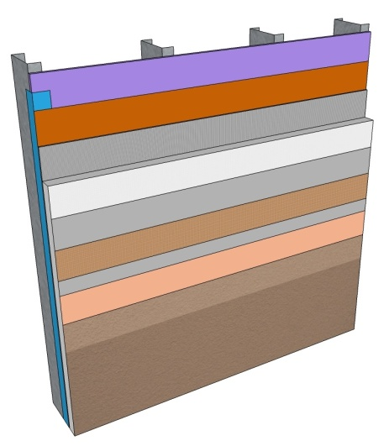

Rollershield Drainage CIFS® 18
- Adds SuperiorFlash at openings and penetrations
- Requires "Plus" adhesive and base coat
- Requires 2-layers Standard Reinforcing Mesh minimum with Corner Roll at corners
- Adds Primecoat Primer
- Requires Superior Finishes with DuroTone pigments
- Adds SuperiorCote HP coating

Rollershield Drainage CIFS® 16
- Adds SuperiorFlash at openings and penetrations
- Requires "Plus" adhesive and base coat
- Requires H-Tech Reinforcing Mesh minimum
- Adds Primecoat Primer
- Adds Clearshield sealer

Rollershield Drainage CIFS® 10
10-year Limited Warranty

1.0 General
This is a short form specification. Refer to Rollershield Drainage CIFS® specifications and details for additional information.

1.1 System Description
The Master Wall® Rollershield Drainage Continuously Insulated Finish System (CIFS®) is a Class PB (Polymer Based) EIF System consisting of a roll-applied water barrier, vertical channel adhesive attachment, insulation board, reinforcing mesh and a textured finish.

1.2 Design Requirements:
A. Reference Master Wall® suggested details and architectural drawings for specific detail requirements.
B. Slope all surfaces a minimum of 1:2 (6” in 12”) to shed water, maximum 12” (305mm) wide.
C. Maximum deflection of substrates shall not exceed L/240.
D. Typical acceptable substrates include unpainted brick, masonry, concrete, Portland cement plaster (stucco), exterior grade gypsum sheathing (ASTM C1396), Glass Fiber Sheathing (ASTM C1177), CDX exterior grade plywood, Exposure 1 Oriented Strand Board (OSB).
E. Expansion joints are required in the cladding at building expansion joints, panel joints, floor lines in wood framed construction, and other areas where significant movement occurs.

1.3 Quality Assurance
A. The Rollershield Drainage System shall be recognized by local building codes.
B. The system shall be meet or exceed ASTM C1397 and detailed in accordance with ASTM E2511.
C. The system shall have been tested for fire performance in accordance with ASTM E108, ASTM E-84, NFPA 265, and NFPA 268.
D. The system shall have been tested for drainage performance in accordance with ASTM E331.

1.4 Job Conditions
A. Store all materials protected from weather and direct sunlight at temperatures above 40oF (5oC).
B. The ambient and wall temperature shall be a minimum of 40oF (5oC) and shall remain so for at least 24 hours after installation.

1.5 Warranty
A. Master Wall Rollershield Drainage CIFS® 10-year limited warranty.

2.0 Products
All components of the Rollershield Drainage System shall be manufactured by Master Wall® and supplied by an authorized distributor.
A. SuperiorShield Water Barrier & Flashing Tapes:
SuperiorShield Rollershield (RS): A 100% pure acrylic-based roll-applied weather-resistive barrier.
SuperiorShield Trowel Grade (TG): A 100% pure acrylic-based trowel grade water-resistive barrier.
SuperiorShield Flashing Tape: A lightweight nonwoven joint treatment material.
B. Master Wall Adhesives:
1. Foam & Mesh Adhesive (F&M), F&M Plus: A 100% pure acrylic-based adhesive that is field mixed with Portland cement.
2. Master Wall® Bagged Base (MBB), MBB Plus: A ready to use dry base that is field mixed with water.
C. Insulation Boards: Master Wall® Insulation Board.
D. Aggre-flex Mesh: Available in Standard, Detail, Hi-Tech, Medium, Strong and Ultra. Minimum Standard Mesh required.
E. Master Wall Base Coats:
1. Foam & Mesh Adhesive (F&M), F&M Plus.
2. Master Wall® Bagged Base (MBB), MBB Plus.
F. Superior Finish: 100% pure acrylic formulation with integral color and texture. Perfect Swirl 2.0, Fine Sand 1.0, Medium Sand 1.5, Versatex 0.5 textures.

3.0 Installation
A. Inspect the substrate to ensure that it is free of all foreign materials that would affect the adhesion of the Rollershield Drainage CIFS® System.
B. Apply the system in strict accordance with Master Wall® specifications, product data sheets, architectural drawings and architectural specifications using the products noted above.
Rollershield Drainage CIFS® 12
12-year Limited Warranty

1.0 General
This is a short form specification. Refer to Rollershield Drainage CIFS® specifications and details for additional information.

1.1 System Description
The Master Wall® Rollershield Drainage Continuously Insulated Finish System (CIFS®) is a Class PB (Polymer Based) EIF System consisting of a roll-applied water barrier, vertical channel adhesive attachment, insulation board, reinforcing mesh and a textured finish.

1.2 Design Requirements:
A. Reference Master Wall® suggested details and architectural drawings for specific detail requirements.
B. Slope all surfaces a minimum of 1:2 (6” in 12”) to shed water, maximum 12” (305mm) wide.
C. Maximum deflection of substrates shall not exceed L/240.
D. Typical acceptable substrates include unpainted brick, masonry, concrete, Portland cement plaster (stucco), exterior grade gypsum sheathing (ASTM C1396), Glass Fiber Sheathing (ASTM C1177), CDX exterior grade plywood, Exposure 1 Oriented Strand Board (OSB).
E. Expansion joints are required in the cladding at building expansion joints, panel joints, floor lines in wood framed construction, and other areas where significant movement occurs.

1.3 Quality Assurance
A. The Rollershield Drainage System shall be recognized by local building codes.
B. The system shall be meet or exceed ASTM C1397 and detailed in accordance with ASTM E2511.
C. The system shall have been tested for fire performance in accordance with ASTM E108, ASTM E-84, NFPA 265, and NFPA 268.
D. The system shall have been tested for drainage performance in accordance with ASTM E331.

1.4 Job Conditions
A. Store all materials protected from weather and direct sunlight at temperatures above 40oF (5oC).
B. The ambient and wall temperature shall be a minimum of 40oF (5oC) and shall remain so for at least 24 hours after installation.

1.5 Warranty
A. Master Wall Rollershield Drainage CIFS® 12-year limited warranty.

2.0 Products
All components of the Rollershield Drainage System shall be manufactured by Master Wall® and supplied by an authorized distributor.
A. SuperiorShield Water Barrier & Flashing Tapes:
SuperiorShield Rollershield (RS): A 100% pure acrylic-based roll-applied weather-resistive barrier.
SuperiorShield Trowel Grade (TG): A 100% pure acrylic-based trowel grade water-resistive barrier.
SuperiorShield Flashing Tape: A lightweight nonwoven joint treatment material.
B. Master Wall Adhesives:
1. Foam & Mesh Adhesive (F&M), F&M Plus: A 100% pure acrylic-based adhesive that is field mixed with Portland cement.
2. Master Wall® Bagged Base (MBB), MBB Plus: A ready to use dry base that is field mixed with water.
C. Insulation Boards: Master Wall® Insulation Board.
D. Aggre-flex Mesh: Available in Standard, Detail, Hi-Tech, Medium, Strong and Ultra. Minimum Standard Mesh required.
E. Master Wall Base Coats:
1. Foam & Mesh Adhesive (F&M), F&M Plus.
2. Master Wall® Bagged Base (MBB), MBB Plus.
F. Primecoat: 100% pure acrylic primer.
G. Superior Finish: 100% pure acrylic formulation with integral color and texture. Perfect Swirl 2.0, Fine Sand 1.0, Medium Sand 1.5, Versatex 0.5 textures.

3.0 Installation
A. Inspect the substrate to ensure that it is free of all foreign materials that would affect the adhesion of the Rollershield Drainage CIFS® System.
B. Apply the system in strict accordance with Master Wall® specifications, product data sheets, architectural drawings and architectural specifications using the products noted above.

Rollershield Drainage CIFS® 16
16-year Limited Warranty

1.0 General
This is a short form specification. Refer to Rollershield Drainage CIFS® specifications and details for additional information.

1.1 System Description
The Master Wall® Rollershield Drainage Continuously Insulated Finish System (CIFS®) is a Class PB (Polymer Based) EIF System consisting of a roll-applied water barrier, vertical channel adhesive attachment, insulation board, reinforcing mesh and a textured finish.

1.2 Design Requirements:
A. Reference Master Wall® suggested details and architectural drawings for specific detail requirements.
B. Slope all surfaces a minimum of 1:2 (6” in 12”) to shed water, maximum 12” (305mm) wide.
C. Maximum deflection of substrates shall not exceed L/240.
D. Typical acceptable substrates include unpainted brick, masonry, concrete, Portland cement plaster (stucco), exterior grade gypsum sheathing (ASTM C1396), Glass Fiber Sheathing (ASTM C1177), CDX exterior grade plywood, Exposure 1 Oriented Strand Board (OSB).
E. Expansion joints are required in the cladding at building expansion joints, panel joints, floor lines in wood framed construction, and other areas where significant movement occurs.

1.3 Quality Assurance
A. The Rollershield Drainage System shall be recognized by local building codes.
B. The system shall be meet or exceed ASTM C1397 and detailed in accordance with ASTM E2511.
C. The system shall have been tested for fire performance in accordance with ASTM E108, ASTM E-84, NFPA 265, and NFPA 268.
D. The system shall have been tested for drainage performance in accordance with ASTM E331.

1.4 Job Conditions
A. Store all materials protected from weather and direct sunlight at temperatures above 40oF (5oC).
B. The ambient and wall temperature shall be a minimum of 40oF (5oC) and shall remain so for at least 24 hours after installation.

1.5 Warranty
A. Master Wall Rollershield Drainage CIFS® 16-year limited warranty.

2.0 Products
All components of the Rollershield Drainage System shall be manufactured by Master Wall® and supplied by an authorized distributor.
A. SuperiorShield Water Barrier & Flashing Tapes:
SuperiorShield Rollershield (RS): A 100% pure acrylic-based roll-applied weather-resistive barrier.
SuperiorShield Trowel Grade (TG): A 100% pure acrylic-based trowel grade water-resistive barrier.
SuperiorShield Flashing Tape: A lightweight nonwoven joint treatment material.
SuperiorShield SuperiorFlash: Single-component STPE Flashing.
B. Master Wall Adhesives:
1. Foam & Mesh Plus Adhesive (F&M Plus): A 100% pure acrylic-based adhesive that is field mixed with Portland cement.
2. Master Wall® Bagged Base Plus (MBB Plus): A ready to use dry base that is field mixed with water.
C. Insulation Boards: Master Wall® Insulation Board.
D. Aggre-flex Mesh: Available in Standard, Detail, Hi-Tech, Medium, Strong and Ultra. Minimum Hi-Tech Mesh required for wall surfaces for the CIFS® 16 System.
E. Master Wall Base Coats:
1. Foam & Mesh Adhesive (F&M), F&M Plus.
2. Master Wall® Bagged Base (MBB), MBB Plus.
F. Primecoat: 100% pure acrylic primer.
G. Superior Finish: 100% pure acrylic formulation with integral color and texture. Perfect Swirl 2.0, Fine Sand 1.0, Medium Sand 1.5, Versatex 0.5 textures.
H. Protective Sealer: Clearshield protective sealer.

3.0 Installation
A. Inspect the substrate to ensure that it is free of all foreign materials that would affect the adhesion of the Rollershield Drainage CIFS® System.
B. Apply SuperiorFlash in and around window and door openings along with all other penetrations in the system as shown in Master Wall® product data sheets.
C. Apply the system in strict accordance with Master Wall® specifications, product data sheets, architectural drawings and architectural specifications using the products noted above.

Rollershield Drainage CIFS® 18
18-year Limited Warranty

1.0 General
This is a short form specification. Refer to Rollershield Drainage CIFS® specifications and details for additional information.

1.1 System Description
The Master Wall® Rollershield Drainage Continuously Insulated Finish System (CIFS®) is a Class PB (Polymer Based) EIF System consisting of a roll-applied water barrier, vertical channel adhesive attachment, insulation board, reinforcing mesh and a textured finish.

1.2 Design Requirements:
A. Reference Master Wall® suggested details and architectural drawings for specific detail requirements.
B. Slope all surfaces a minimum of 1:2 (6” in 12”) to shed water, maximum 12” (305mm) wide.
C. Maximum deflection of substrates shall not exceed L/240.
D. Typical acceptable substrates include unpainted brick, masonry, concrete, Portland cement plaster (stucco), exterior grade gypsum sheathing (ASTM C1396), Glass Fiber Sheathing (ASTM C1177), CDX exterior grade plywood, Exposure 1 Oriented Strand Board (OSB).
E. Expansion joints are required in the cladding at building expansion joints, panel joints, floor lines in wood framed construction, and other areas where significant movement occurs.

1.3 Quality Assurance
A. The Rollershield Drainage System shall be recognized by local building codes.
B. The system shall be meet or exceed ASTM C1397 and detailed in accordance with ASTM E2511.
C. The system shall have been tested for fire performance in accordance with ASTM E108, ASTM E-84, NFPA 265, and NFPA 268.
D. The system shall have been tested for drainage performance in accordance with ASTM E331.

1.4 Job Conditions
A. Store all materials protected from weather and direct sunlight at temperatures above 40oF (5oC).
B. The ambient and wall temperature shall be a minimum of 40oF (5oC) and shall remain so for at least 24 hours after installation.

1.5 Warranty
A. Master Wall Rollershield Drainage CIFS® 18-year limited warranty.

2.0 Products
All components of the Rollershield Drainage System shall be manufactured by Master Wall® and supplied by an authorized distributor.
A. SuperiorShield Water Barrier & Flashing Tapes:
SuperiorShield Rollershield (RS): A 100% pure acrylic-based roll-applied weather-resistive barrier.
SuperiorShield Trowel Grade (TG): A 100% pure acrylic-based trowel grade water-resistive barrier.
SuperiorShield Flashing Tape: A lightweight nonwoven joint treatment material.
SuperiorShield SuperiorFlash: Single-component STPE Flashing.
B. Master Wall Adhesives:
1. Foam & Mesh Plus Adhesive (F&M Plus): A 100% pure acrylic-based adhesive that is field mixed with Portland cement.
2. Master Wall® Bagged Base Plus (MBB Plus): A ready to use dry base that is field mixed with water.
C. Insulation Boards: Master Wall® Insulation Board.
D. Aggre-flex Mesh: Available in Standard, Detail, Hi-Tech, Medium, Strong and Ultra with Corner Roll. Minimum two-layers of Standard Mesh with Corner Roll required for wall surfaces for the CIFS® 18 System.
E. Master Wall Base Coats:
1. Foam & Mesh Adhesive (F&M), F&M Plus.
2. Master Wall® Bagged Base (MBB), MBB Plus.
F. Primecoat: 100% pure acrylic primer.
G. Superior Finish: 100% pure acrylic formulation with integral color and texture. Perfect Swirl 2.0, Fine Sand 1.0, Medium Sand 1.5, Versatex 0.5 textures with DuroTone pigments.
H. Protective Coating: SuperiorCote HP hydrophobic coating.

3.0 Installation
A. Inspect the substrate to ensure that it is free of all foreign materials that would affect the adhesion of the Rollershield Drainage CIFS® System.
B. Apply SuperiorFlash in and around window and door openings along with all other penetrations in the system as shown in Master Wall® product data sheets.
C. Apply the system in strict accordance with Master Wall® specifications, product data sheets, architectural drawings and architectural specifications using the products noted above.

Disclaimer
This Specification is published for general informational purposes only and is not intended to imply that these are the only materials, procedures, or methods, which are available or suitable. Materials, procedures, or methods may vary according to the particular circumstances, local building code requirements, design conditions, or statutory and regulatory requirements. While the information in this specification is believed to be accurate and reliable, it is presented without guarantee or responsibility on the part of Master Wall Inc.®

