

Master Wall Inc.®
PO Box 397
Fortson, GA 31808
706-569-0092
800-755-0825
www.masterwall.com

Master Wall Guide Specification RDCIFS10
Rollershield Drainage CIFS® 10 Assembly
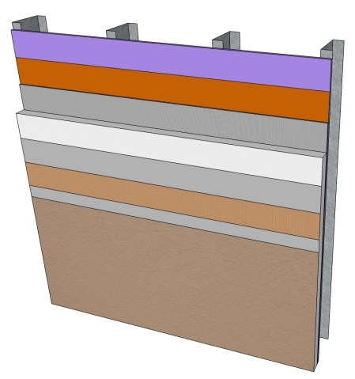

Rollershield Drainage CIFS® 10
- Rollershield Air/Water Barrier
- Master Wall Adhesive
- Master Wall Insulation Board
- Standard Mesh minimum
- Master Wall Base Coat
- Superior Finish

Rollershield Drainage CIFS® 10
10-year Limited Warranty

1.0 General
This is a short form specification. Refer to Rollershield Drainage CIFS® specifications and details for additional information.

1.1 System Description
The Master Wall® Rollershield Drainage Continuously Insulated Finish System (CIFS®) is a Class PB (Polymer Based) EIF System consisting of a roll-applied water barrier, vertical channel adhesive attachment, insulation board, reinforcing mesh and a textured finish.

1.2 Design Requirements:
A. Reference Master Wall® suggested details and architectural drawings for specific detail requirements.
B. Slope all surfaces a minimum of 1:2 (6” in 12”) to shed water, maximum 12” (305mm) wide.
C. Maximum deflection of substrates shall not exceed L/240.
D. Typical acceptable substrates include unpainted brick, masonry, concrete, Portland cement plaster (stucco), exterior grade gypsum sheathing (ASTM C1396), Glass Fiber Sheathing (ASTM C1177), CDX exterior grade plywood, Exposure 1 Oriented Strand Board (OSB).
E. Expansion joints are required in the cladding at building expansion joints, panel joints, floor lines in wood framed construction, and other areas where significant movement occurs.

1.3 Quality Assurance
A. The Rollershield Drainage System shall be recognized by local building codes.
B. The system shall be meet or exceed ASTM C1397 and detailed in accordance with ASTM E2511.
C. The system shall have been tested for fire performance in accordance with ASTM E108, ASTM E-84, NFPA 265, and NFPA 268.
D. The system shall have been tested for drainage performance in accordance with ASTM E331.
1.4 Job Conditions
A. Store all materials protected from weather and direct sunlight at temperatures above 40oF (5oC).
B. The ambient and wall temperature shall be a minimum of 40oF (5oC) and shall remain so for at least 24 hours after installation.

1.5 Warranty
A. Master Wall Rollershield Drainage CIFS® 10-year limited warranty.

2.0 Products
All components of the Rollershield Drainage System shall be manufactured by Master Wall® and supplied by an authorized distributor.
A. SuperiorShield Water Barrier & Flashing Tapes:
SuperiorShield Rollershield (RS): A 100% pure acrylic-based roll-applied weather-resistive barrier.
SuperiorShield Trowel Grade (TG): A 100% pure acrylic-based trowel grade water-resistive barrier.
SuperiorShield Flashing Tape: A lightweight nonwoven joint treatment material.
B. Master Wall Adhesives:
1. Foam & Mesh Adhesive (F&M), F&M Plus: A 100% pure acrylic-based adhesive that is field mixed with Portland cement.
2. Master Wall® Bagged Base (MBB), MBB Plus: A ready to use dry base that is field mixed with water.
C. Insulation Boards: Master Wall® Insulation Board.
D. Aggre-flex Mesh: Available in Standard, Detail, Hi-Tech, Medium, Strong and Ultra. Minimum Standard Mesh required.
E. Master Wall Base Coats:
1. Foam & Mesh Adhesive (F&M), F&M Plus.
2. Master Wall® Bagged Base (MBB), MBB Plus.
F. Superior Finish: 100% pure acrylic formulation with integral color and texture. Perfect Swirl 2.0, Fine Sand 1.0, Medium Sand 1.5, Versatex 0.5 textures.

3.0 Installation
A. Inspect the substrate to ensure that it is free of all foreign materials that would affect the adhesion of the Rollershield Drainage CIFS® System.
B. Apply the system in strict accordance with Master Wall® specifications, product data sheets, architectural drawings and architectural specifications using the products noted above.

Disclaimer
This Specification is published for general informational purposes only and is not intended to imply that these are the only materials, procedures, or methods, which are available or suitable. Materials, procedures, or methods may vary according to the particular circumstances, local building code requirements, design conditions, or statutory and regulatory requirements. While the information in this specification is believed to be accurate and reliable, it is presented without guarantee or responsibility on the part of Master Wall Inc.®

